Daily Report

Department: Mechanical Engineering Date: 02- April - 2026

- Staff Attendance:

S.No | Dept. | Category | On Rolls | Absent | Details/Remarks
4 | Mechanical Engineering | Teaching | 36 | 00 | 01. Faculty – On Duty  01. Dr Dangeti Sarath Chandra - OD  00 Faculty – Casual / Earn Leave  - Full Day  Half Day  01. Dr Hazari Naresh  00Faculty – Half Pay Leave  00 Faculty - Study Leave  00Faculty-Maternity/Paternity Leave
 |  | Non- Teaching | 13 | 00 | 00 Staff– On Duty  00 Staff- Casual / Earn Leave  - Full Day  Half Day  00 Staff -Study Leave  00Staff-Maternity/Paternity Leave
Infrastructure issues or Maintenance:
S.No. | Description of the problem | Reported  On | Attended  On | Completed on | Remarks
1.

- Event (short term course / workshops/Seminar, etc.) organized:

S.No | Name of the Event-seminar/ short term course / workshops, etc | Duration | For Whom | No. of Participants |  | Resource  Person/Faculty | Remarks
 |  |  |  | VNRVJIET | Others
1.

- Participation by Staff:

S. No | Name | Event | Status (delegate /paper) Present, speaker) | Date and Duration

- Participation by Students:

S. No | Name | Event | Status (delegate /paper) Present, speaker) | Date and Duration

- Staff joined or left

S.No | Name of the Faculty | Designation | Date of joining/leaving | Remarks

- Classwork Adjustment / Lectures Interchanged:

S. No | Dept | Subject | Time | Adjusted from | Adjusted to
 | ME

- Incident if any (Discipline of staff or students, etc.)

S.No | Name | R. No. or ID No. | Brief statement | Remarks
9. Industrial training to Teachers/Students/Staff-
S.  No. | Staff/Student | Industry Visited | Date of the Visit | Location of the Industry | No. of students  Visited
OTHER MATTERS:
- Dr. K. Krishna Murthy, Assistant Professor/Mechanical Engineering, along with EEE faculty and students, visited TRUDARE TECHNO, Phase IV, Quthbullapur, Jeedimetla, Hyderabad – 500055, Telangana, on 01-04-2026.”
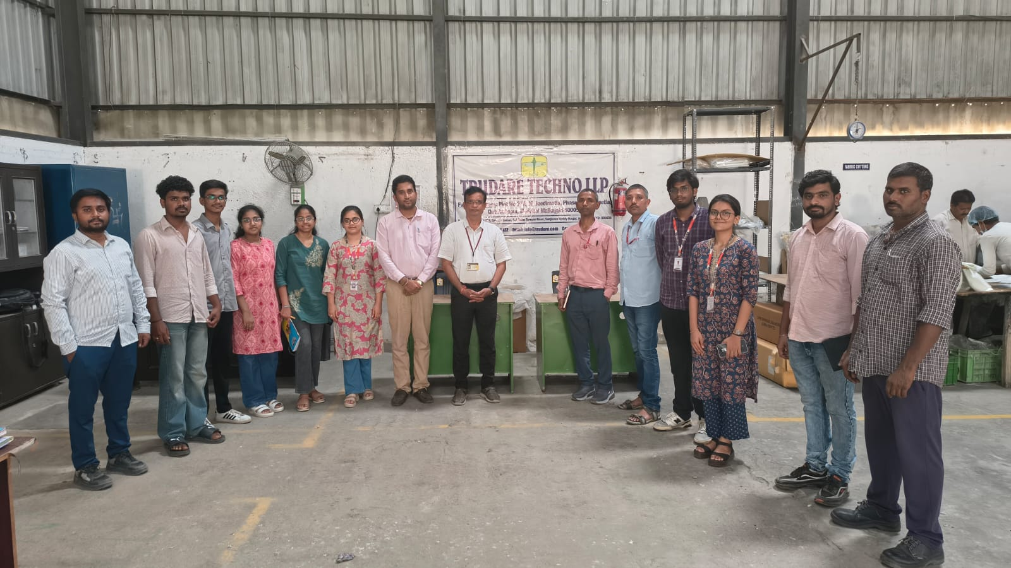
Dr. B. V. R. Ravi Kumar
HOD – ME

